DATA ANALYSIS INTERNSHIP – DAY 9 REPORT
Organization: Top Tech Developers
Topic Covered: Student Performance Analysis using Pandas and Matplotlib
On Day 9 of the internship, the Student Performance dataset downloaded from Kaggle was analyzed using Pandas in Google Colab. The dataset contained 1499 rows and 12 columns related to student study hours, subject scores, grades, gender, and email details. Various dataframe operations, statistical functions, filtering techniques, string functions, and visualization concepts using Matplotlib were practiced.

1. Dataset Loading
The student dataset was loaded into a Pandas dataframe for analysis.
Function Used
- pd.read_csv()
Purpose
- Used to load the Kaggle student performance dataset into a dataframe.
- Converts CSV data into tabular format for processing.

2. Dataset Inspection
Basic inspection functions were performed to understand dataset structure.
Functions Used
- head()
- tail()
- shape
- columns
- dtypes
- info()
- describe()
Purpose
These functions were used to:
- View dataset rows and columns
- Check datatypes
- Understand dataset structure
- Display statistical summaries

3. Null Value Checking
The dataset was checked for missing values.
Function Used
- df.isnull()
Purpose
- Identifies missing or null values in the dataset.
- Helps maintain data quality before analysis.

4. Statistical Operations
Statistical functions were applied to analyze subject score columns.
Functions Used
- sum()
- mean()
- mode()
- max()
- min()
- count()
- std()
Operations Performed
- Total math score calculation
- Average weekly self-study hours
- Most repeated gender value
- Highest history score
- Lowest physics score
- Total number of student IDs
- Standard deviation of geography scores

5. Sorting and Duplicate Handling
Sorting and duplicate management functions were practiced.
Functions Used
- sort_index()
- drop_duplicates()
Purpose
- Sorting dataframe indexes
- Removing duplicate records

6. Column Operations
Various dataframe modification functions were performed.
Functions Used
- drop()
- rename()
- insert()
- replace()
- astype()
Operations Performed
- Removed Email column
- Renamed weekly study hours column
- Inserted Age column
- Replaced values in dataframe
- Converted datatype into float format

7. Filtering and Query Operations
Conditional filtering was performed to retrieve specific student records.
Functions Used
- query()
- Conditional dataframe indexing
Examples
- Students with math score greater than 90
- Students with history score greater than 80
- Students with english score equal to 90
Purpose
- Used to filter and retrieve specific student records based on conditions.

8. Sampling Operation
A random row was displayed from the dataframe.
Function Used
- df.sample(1)
Purpose
- Displays random rows from the dataframe.
- Useful for testing and inspection.

9. Indexing Operations
Indexing functions were practiced.
Functions Used
- loc[]
- set_index()
Purpose
Used for:
- Accessing rows using labels
- Setting the Id column as dataframe index

10. Grouping Operation
Grouping and aggregation were performed.
Function Used
- df.groupby("Id").sum()
Purpose
- Groups similar data together
- Performs aggregation operations

11. Merge Operation
Two datasets were combined using merge.
Function Used
- pd.merge(df, df2, on="Id")
Purpose
- Combines datasets based on a common column.

12. NumPy Conversion
The dataframe was converted into NumPy array format.
Function Used
- df.to_numpy()
Purpose
- Converts dataframe into NumPy array format for numerical operations.

13. String Functions
String operations were applied on text columns.
Functions Used
- upper()
- capitalize()
- len()
- contains()
- startswith()
Purpose
- Used for text formatting and string analysis.

14. Series Function
A Pandas Series object was created.
Function Used
- pd.Series([df])
Purpose
- Creates a Pandas Series object.

15. Unique Value Counting
Unique value counts were calculated.
Function Used
- df.nunique()
Purpose
- Counts unique values in each dataframe column.

16. Introduction to Matplotlib
Matplotlib is a Python library used for data visualization. It helps create graphs, charts, and plots for understanding data easily.
Import Statement
import matplotlib.pyplot as plt
Usage of Matplotlib
- Creating graphs and charts
- Data visualization
- Comparing values
- Finding trends and patterns
- Used in data analysis and machine learning

17. Functions in Matplotlib
The following graph plotting functions were learned:
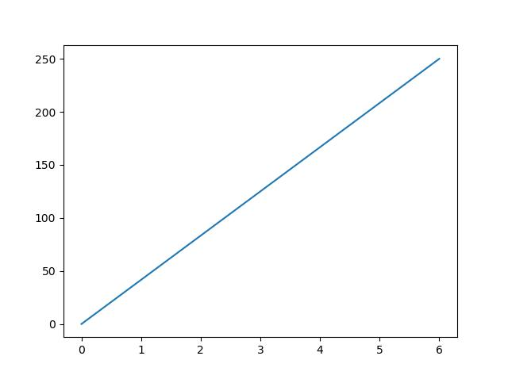
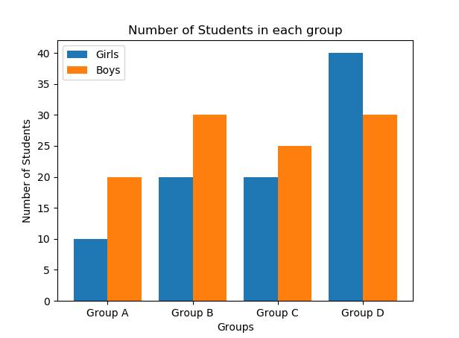
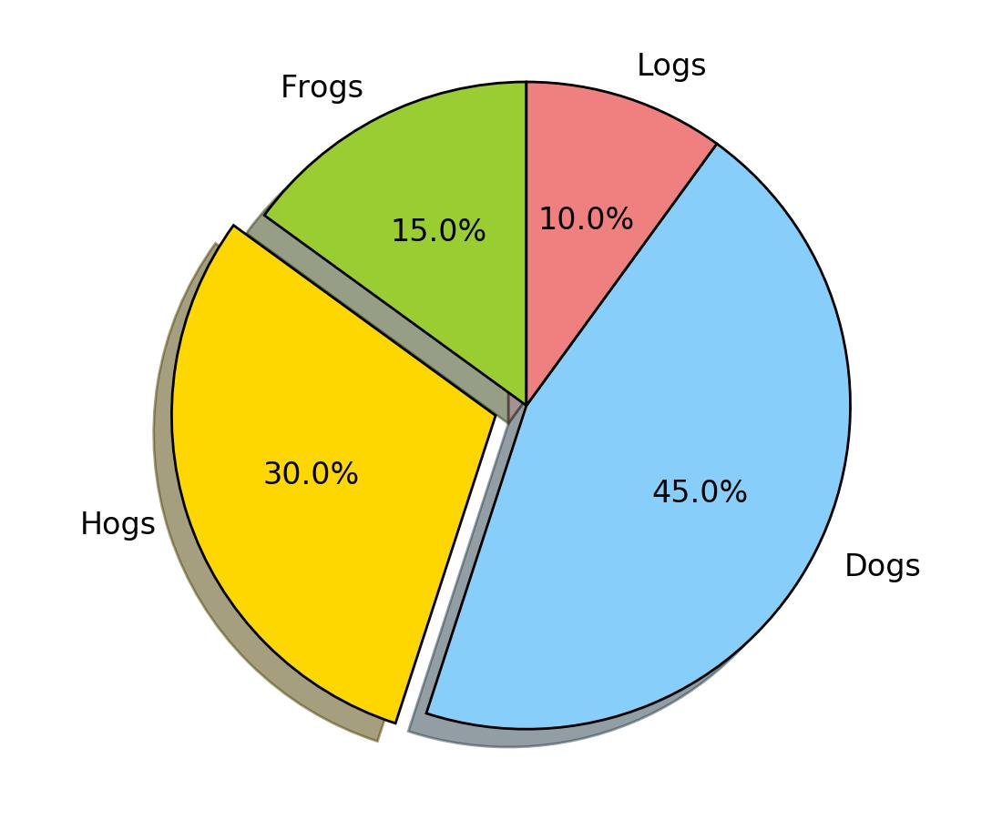
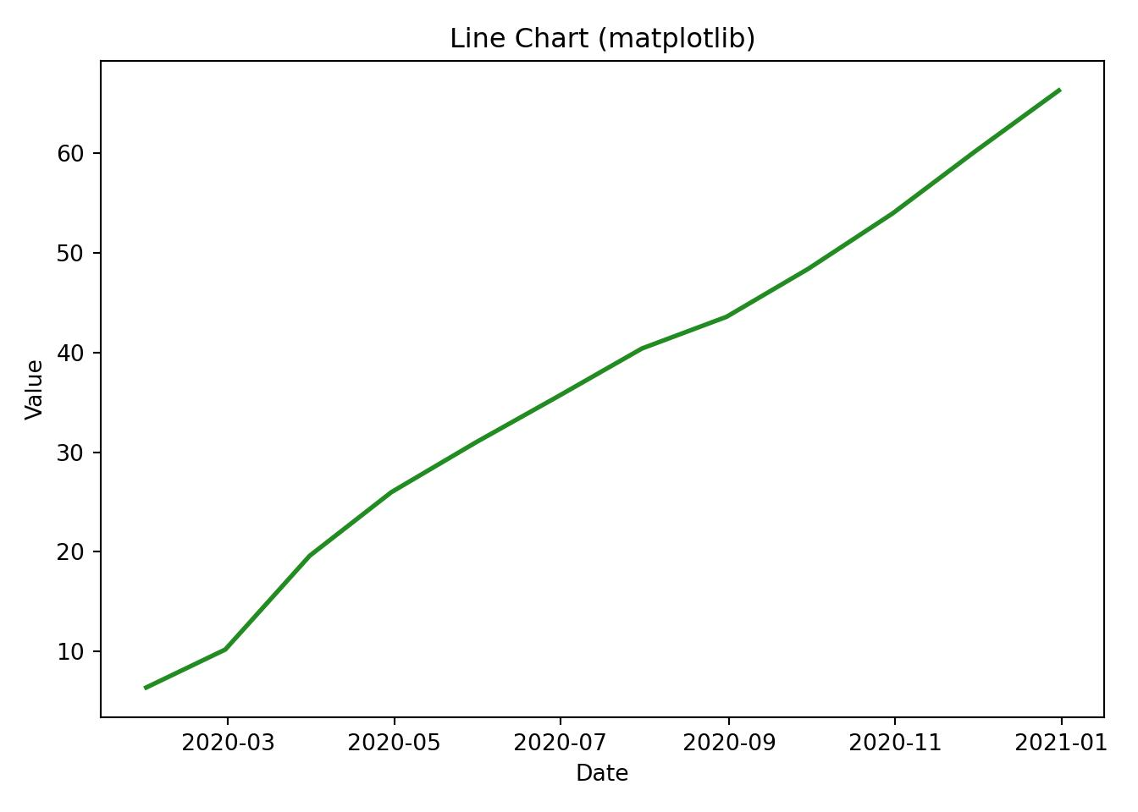
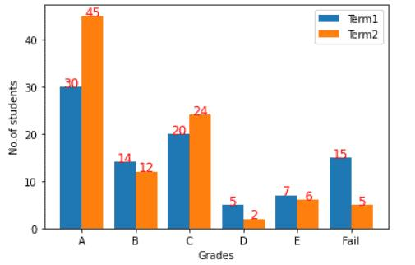
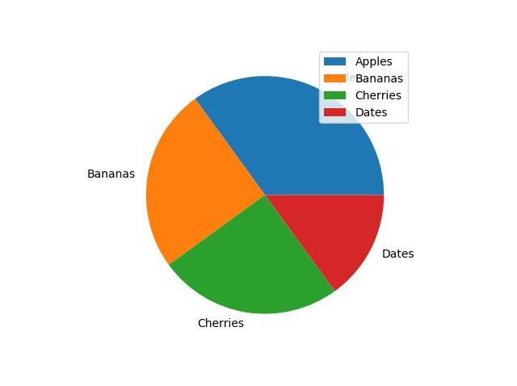
Functions Practiced
- plot() – Creates line graph
- bar() – Creates vertical bar chart
- barh() – Creates horizontal bar chart
- scatter() – Creates scatter plot
- hist() – Creates histogram
- pie() – Creates pie chart
- xlabel() – Adds x-axis label
- ylabel() – Adds y-axis label
- title() – Adds title
- legend() – Displays labels
- grid() – Adds grid lines
- show() – Displays graph
- figure() – Creates new figure
- subplot() – Creates multiple graphs
- savefig() – Saves graph as image

Technologies Used
- Python
- Pandas
- NumPy
- Matplotlib
- Google Colab

Learning Outcome
On Day 9, I learned how Pandas and Matplotlib are used for data analysis and visualization.
I understood:
- how to inspect and analyze datasets
- how to perform filtering and statistical operations
- how to modify dataframe columns
- how to merge and group datasets
- how to convert dataframes into NumPy arrays
- how to apply string functions
- how to create graphs and charts using Matplotlib
- how graphical visualization helps understand data patterns

Conclusion
The Day 9 internship session helped me understand practical data analysis and visualization using Pandas and Matplotlib. I performed dataset inspection, statistical calculations, filtering, grouping, merging, and string processing using the Student Performance dataset.
Additionally, I learned how to create different graphs such as line charts, bar charts, scatter plots, histograms, and pie charts using Matplotlib. This session improved my understanding of data handling, visualization, and graphical representation in Python.

